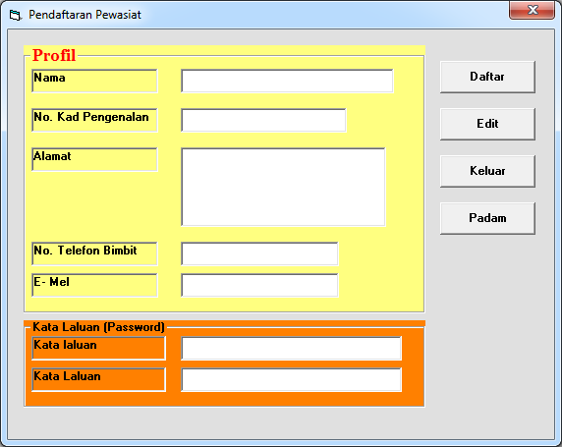
txtnama
txticno
txtalamat
txtnotel
txtemail
cmdsimpan
cmdedit
cmdkeluar
cmdpadam
Txtkatalaluan1
Txtkataluluan2

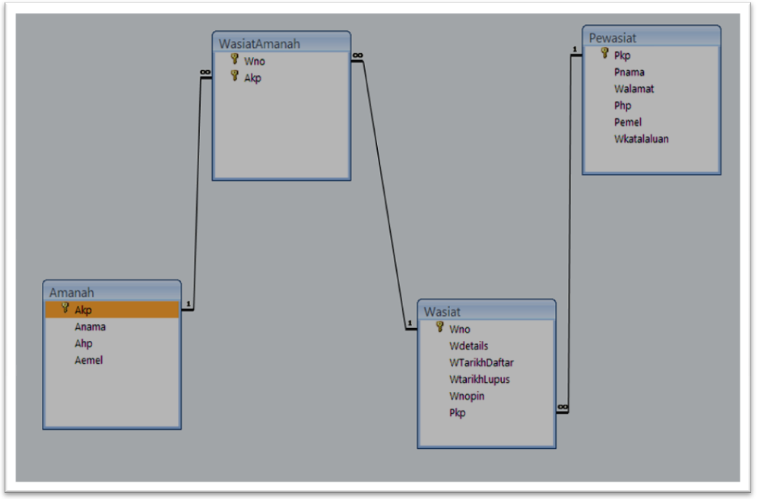
How To Create Module
- Click Menu Project
- Click Add Module
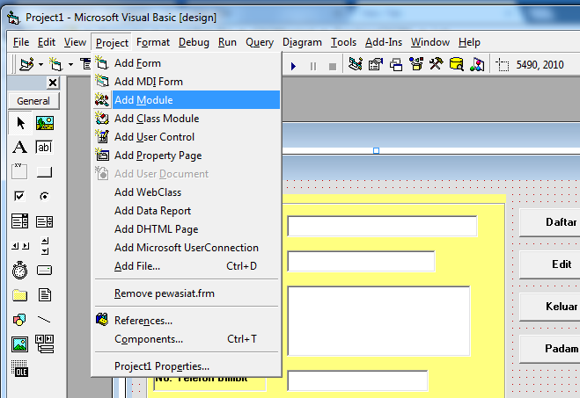
Dialogue box below will appear.
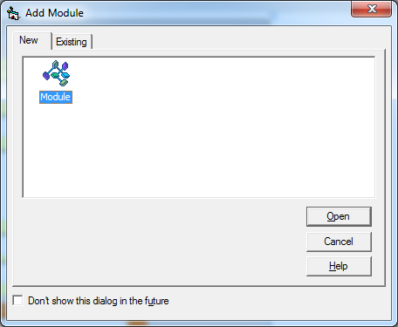
Click button Open
Copy coding below into the module

Option Explicit

Public dbwasiat As Database ‘open wasiat database
Public rs1 As Recordset ‘declaring table in the database , if you have 4 tables you should have
Public rs2 As Recordset ‘4 recordset
Public rs3 As Recordset
Public rs4 As Recordset

'------------------------------------------------------------------------
‘ Procedure to open the wasiat database
‘------------------------------------------------------------------------
Public Sub OpenWasiatDatabase()

Set dbwasiat = OpenDatabase(GetAppPath() & "wasiat.mdb")

End Sub

‘----------------------------------------------------------------------
‘Procedure to open Pewasiat table
‘----------------------------------------------------------------------
Public Sub OpenPewasiatTable()

Set rs1 = dbwasiat.OpenRecordset("pewasiat")

End Sub

‘----------------------------------------------------------------------
‘Procedure to open Amanah table
‘----------------------------------------------------------------------

Public Sub OpenAmanahTable()

Set rs2 = dbwasiat.OpenRecordset("amanah")

End Sub

‘----------------------------------------------------------------------
‘Procedure to open Wasiat table
‘----------------------------------------------------------------------
Public Sub OpenWasiatTable()

Set rs3 = dbwasiat.OpenRecordset("wasiat")

End Sub

‘----------------------------------------------------------------------
‘Procedure to open WasiatAmanah table
‘----------------------------------------------------------------------

Public Sub OpenWasiatAmanahTable()

Set rs4 = dbwasiat.OpenRecordset("WasiatAmanah ")

End Sub

'------------------------------------------------------------------------
‘Procedure to close wasiat database
'------------------------------------------------------------------------
Public Sub CloseEmpDatabase()

dbwasiat.Close
Set dbwasiat = Nothing

End Sub

'------------------------------------------------------------------------
Public Sub CenterForm(pobjForm As Form)
'------------------------------------------------------------------------

With pobjForm
.Top = (Screen.Height - .Height) / 2
.Left = (Screen.Width - .Width) / 2
End With

End Sub

'------------------------------------------------------------------------
Public Function GetAppPath() As String
'------------------------------------------------------------------------

GetAppPath = IIf(Right$(App.Path, 1) = "\", App.Path, App.Path & "\")

End Function

Sample Code for Add , Edit and Delete Record in the table

‘Procedure to Add Record
Private Sub cmdAdd_Click()
OpenWasiatDatabase ' call procedure openWasiatdatabase to open the Wasiat database
OpenPewasiatTable ' open student table in the Wasiat database file

rs1.AddNew
rs1!pnama = Txticno
rs1!pkp = txticno
rs1!palamat= txtalamat
rs1!php = txtnotel
rs1!pemel= txtemail
rs1!pkatalaluan = txtkatalaluan1
rs1.Update

MsgBox "One record has been added ", vbOKOnly, "Add Record"
cmdclear_Click
CloseEmpDatabase

End Sub

‘Procedure to Delete Record

Private Sub cmdDelete_Click()
'Form Load Event
'Set db=OpenDatabase(<<Your MsAccess Filename with path in Double Quotes>>)
'Example
'-------
'Set db = OpenDatabase("d:\vb6\staff.mdb")
'Set rs= db.OpenRecordset(<<Your MsAccess Table Name in double quotes>>)
'Example
'-------
Dim strans,stricno As String

OpenWasiatDatabase 'open the OpenWasiatDatabase function in the module
OpenPewasiatTable
stricno = (txticno)
rs1.MoveFirst

'nostaff adalah nama index key dalam staff table
'to create index field , open table , click icon index , namakan filed index
'selalunya field Primary Key

rs1.Index = "pkp"
rs1.Seek "=", strsicno
If rs1.NoMatch Then
MsgBox "sorry no record found", vbOKOnly, "sorry"
Else
strans = MsgBox("Are Sure You Want To Delete This Record" & vbCrLf & "Name : " & (rs1.Fields("pnama").Value), vbYesNo, "Comfirmation")
If strans = vbYes Then
rs1.Delete
MsgBox "One Record Been Deleted", 16, "Record Delete"
End If
End If
cmdclear_Click
rs1.Close
Set rs1 = Nothing

End Sub

‘Procedure to Search Record
Private Sub cmdSearch_Click()
Dim stricno As String

OpenWasiatDatabase 'open the OpenWasiatDatabase function in the module
OpenPewasiatTable

stricno = Txticno
rs1.Index = "pkp"
rs1.Seek "=", stricno
If rs1.NoMatch Then
MsgBox "Sorry no record found", vbOKOnly, "sorry"
Else
txticno = rs1!pkp
txtnama=rs1!pnama
txtnotel = rs1!php
txtalamat = rs1!palamat
txtemail =rs1!pemel
txtkatalaluan=rs1!pkatalaluan

End If

End Sub

‘Procedure to Edit Record

Private Sub cmdUpdate_Click()
Dim strans, stricno As String

OpenWasiatDatabase 'call procedure openWasiat to open the Wasiat database
OpenPewasiatTable ' open student table in the Wasiat database file

stricno = Txticno
rs1.Index = "subject_code"
rs1.Seek "=", stricno
rs1.Edit
rs1!subject_name = UCase(txticno)
rs1!subject_contacthrs = Val(txtalamat)
rs1!subject_credithrs = Val(txtnotel)
rs1.Update
MsgBox "Record had been Updated ", vbOKOnly, "Add Record"
cmdclear_Click
CloseEmpDatabase
End Sub

‘ Procedure To Clear Text Box
Private Sub cmdclear_Click()
txtnama = ""
txtalamat = ""
txticno = ""
txtnotel = ""
txtemail= ""
txtkatalaluan = ""
txtkatalaluan1 = ""
End Sub

Before You can test your program , you have to set the project properties.
- Click Menu Project
- Click Reference
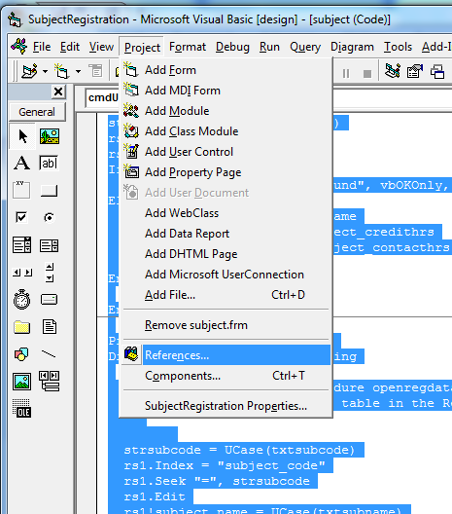

- You will get screen as shown below
- Tick option Microsoft DAO 3.6 Object Library
- Click OK
